**Inertia  
  
A movement based objective game  
by Jonathan Berkeley & Mark Hurley**

Table of Contents

Introduction 3

Requirements gathering 4

Similar applications 4

Personas 13

Interviews 15

Survey 16

Functional requirements 24

Non-functional requirements 24

Use Case Diagram 26

Feasibility 27

Conclusion 28

Tools and information 29

## Introduction

The product being developed is a single player 3D movement-based physics game, where the player assumes control of an unnamed test subject who is armed only with a grappling gun. This unnamed test subject has the objective of escaping the laboratory they are trapped in by solving various puzzles using the grappling gun and their wits.

The game is very beginner friendly but can also be a challenge for those who have are interested in beating the game in the fastest time possible. The game requires the player to make their way from one end of the level to the other while jumping across and around platforms. It will be a relatively short game with the main focus being on the unique gameplay and level design.

This game will be made in Unity and will also be using Unity collaborate and Github to share the project between developers as they work on it. The game will be coded in C sharp (C#).

## Requirements gathering

### Similar applications

Portal 2: <https://store.steampowered.com/app/620/Portal_2/>

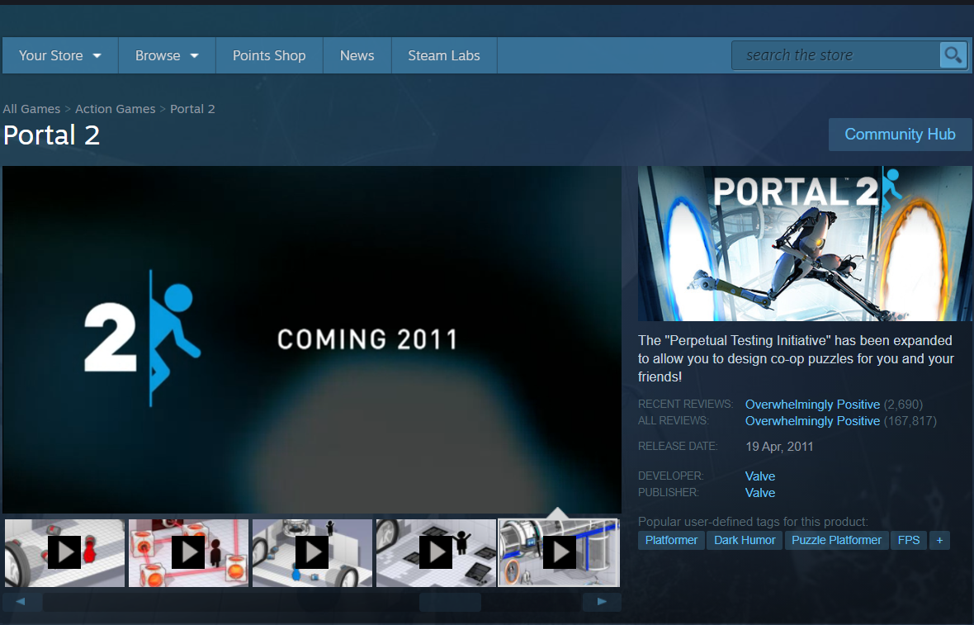

Figure 1Portal 2 home page on steam

Portal 2 is an Action Adventure, First Person, Puzzle Game that can be played in both single player and co – operative multiplayer. The single player game portion of the game takes place in a laboratory where the player takes control of a test subject trying to escape the lab while solving various puzzles along the way using a portal gun which used by placing an orange coloured portal on one and a blue coloured portal on a different surface as seen in the example below.

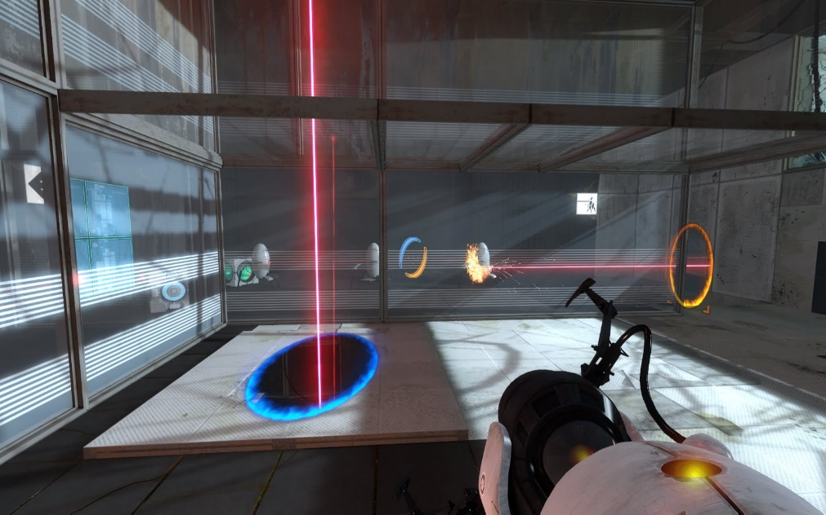

Figure 2, example of the portal concept

As for the multiplayer side two players take control of two robots using portal mechanics as described above to solve various puzzles together with a narrative of freeing frozen test subjects in the lab. An example is shown below.

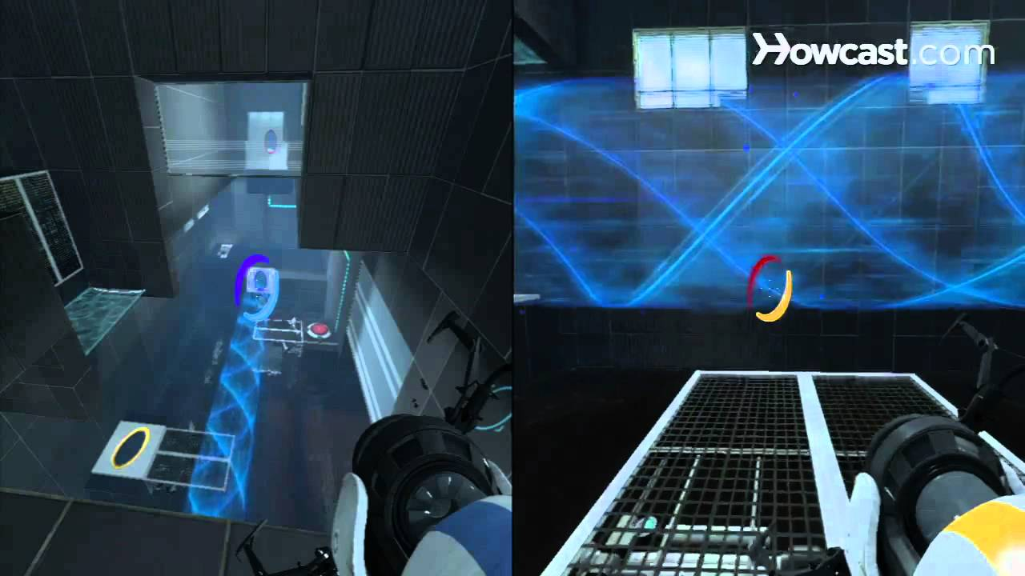

Figure 3 example of co-op play

Advantages:

* Provides the user to experience the game alone or with a friend
* Has a strong narrative in both single player and co-op
* Has great characters and great voice acting performances
* Has great and unique gameplay

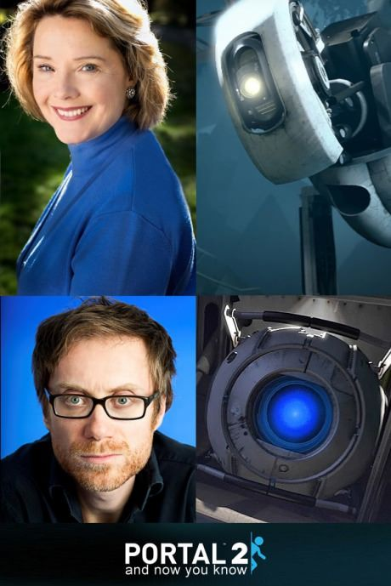

Figure 4 Actors Ellen McLain and Stephen Merchant next to the characters they voice

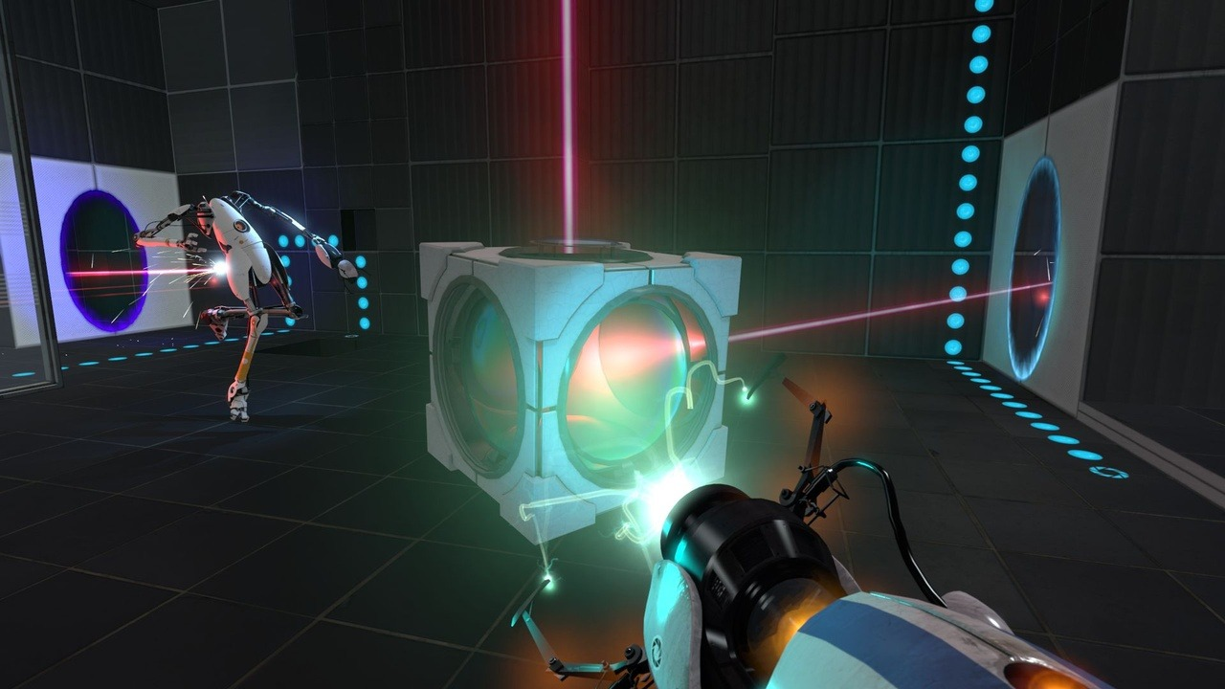

Figure 5 Example of unique mechanics

Disadvantages:

* Has aged graphics
* Is considered too easy for some
* Is relatively short game

Refunct: <https://store.steampowered.com/app/406150/Refunct/>

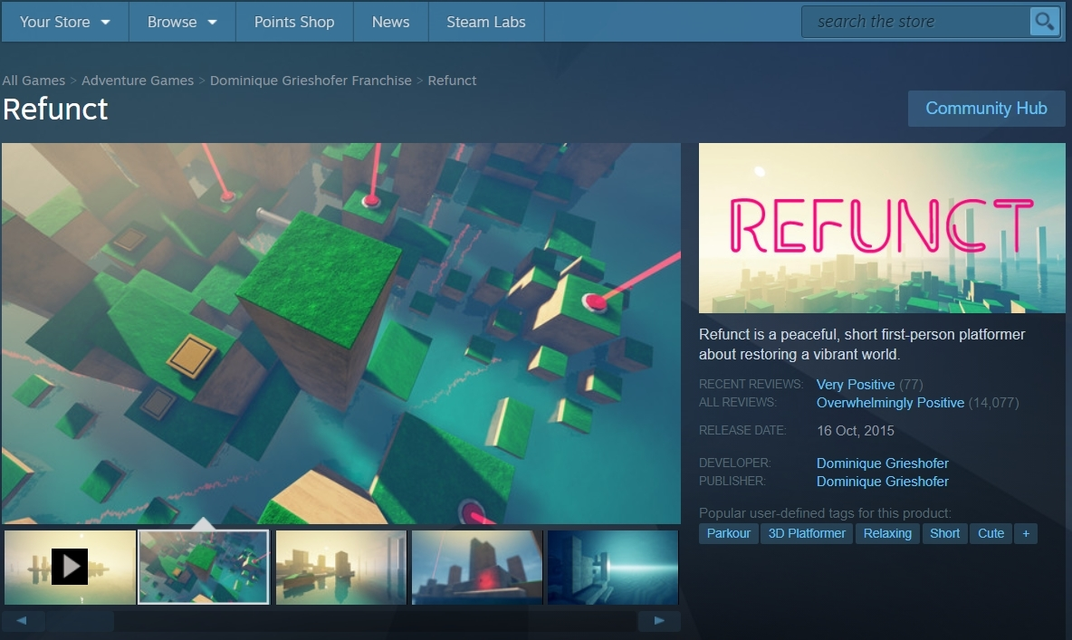

Figure 6 Refunct’s home page on steam

Refunct is a small and calm Single Player, First Person, Puzzle, Platformer game where the player is tasked with getting from point A to B with no real narrative, but focuses more on the

visual aspects of the game with nice soothing colours and great ambience. An example is provided below.

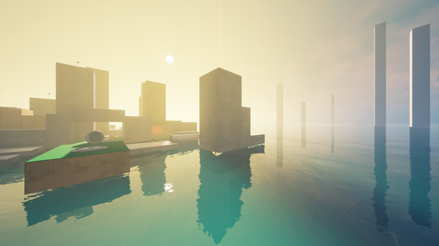

Figure 7 an example of Refunct’s beautiful world

Advantages:

* Amazing visuals and music
* Relaxing setting and tone
* Easy to learn and hard to master puzzles
* Great gameplay

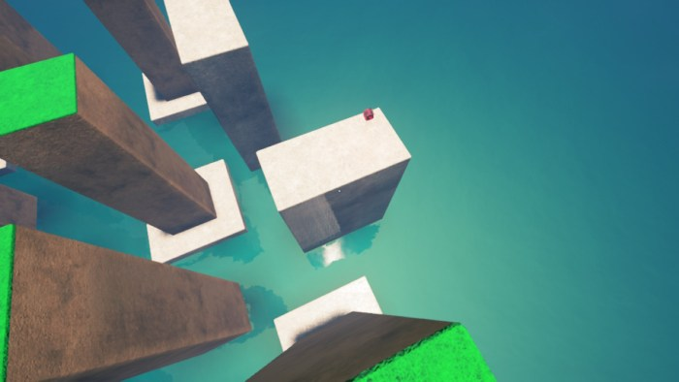

Figure 8 an example of Refunct’s gameplay

Disadvantages:

* Might be considered too short for hardcore puzzle game fans
* No story if the user is looking for a story driven experience
* Not much replayability

The Stanley Parable: <https://store.steampowered.com/app/221910/The_Stanley_Parable/>

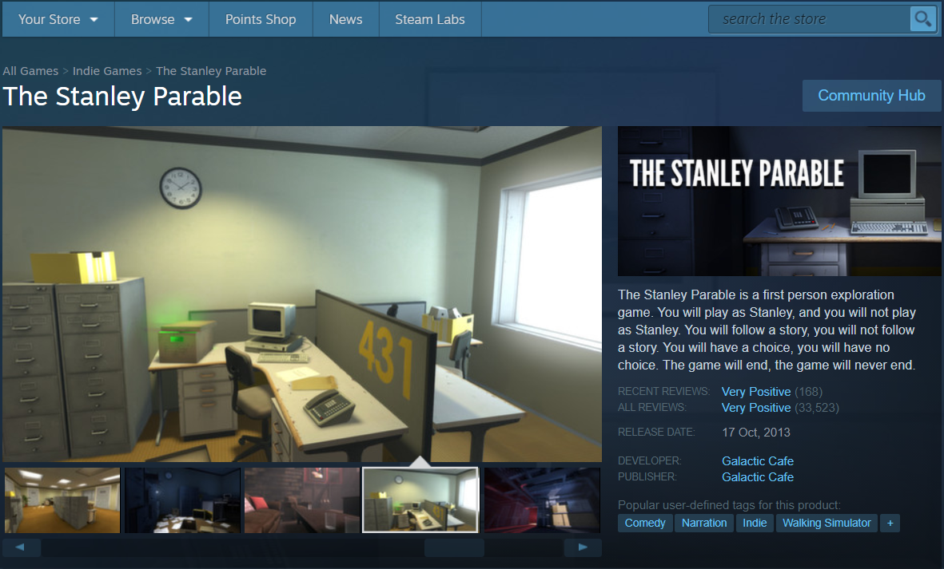

Figure 9 The Stanley Parable home page on Steam

The Stanley Parable is a Single Player, Story Driven, Comedy, First Person, Puzzle game where you assume the role of a man named Stanley whose goal is to do as the narrator says or do something else entirely, the choice is left up to the player.

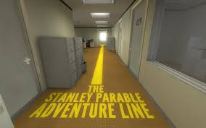

Figure 10 an example of the kind of gameplay in this game

Advantages:

* A very unique and clever game
* Has some great and funny writing/dialogue
* Has tonnes of replayability
* Interesting story
* Multiple pathways and endings

Disadvantages:

* Limited Gameplay
* Can be considered too easy
* Not for the impatient

### Personas

Figure 11 Courtney Persona

Figure 12 Brendan Persona

### Interviews

In the interviews conducted, participants were asked the same set of questions about gaming in general. From this, it was discovered what the participants liked and disliked about gaming. Some shared similar opinions while others had vastly different ones.

Everyone interviewed each said that they enjoy playing games and they would all consider themselves ‘Gamers’, which is the demographic the product is aimed towards so that the survey will get only the most relevant answers. When asked how often they would spend playing video games in a given week the results ranged from 1 or 2 hours (only during very limited free time) to playing daily for upwards of 5-6 hours daily. This shows that the project developers need to be mindful of those who do not have enough free time to play games but also of those who spend all of their free time playing games. The developers of this game need to strike a good middle ground for the game between hardcore gaming and casual gaming.

Everyone interviewed also seemed to primarily play on the same platform (PC) alongside some secondary console of preference. This is good for us as the game is being developed to be played on PC. When asked about favourite game genre, a variety of responses was received. The majority of responses listed RPGS as their favourite game genre. Everyone interviewed said that they have all played portal 2 which is one of the games listed above and that they thoroughly enjoyed it. This is great news for development as Inertia is heavily inspired by portal 2. When asked about the most important aspect of a game it appeared to be a 50/50 split among the people interviewed between story and gameplay which is quite interesting.

# Survey

The survey created for this project consists of several questions aimed at finding out how much interest there would be for this type of game. It aims to find out how much awareness and interest there is for the game genre that the project is targeting, and to find out what people thought would be most important aspects/mechanics of a game in this genre. The survey was sent to all college students in IADT Creative Computing Year 3, and to some other students from other courses, all of whom are over 18 years old. The survey was not sent to anyone under 18 years old for ethical reasons. The survey received 12 responses since it was published on 16th Oct 2020 to 30th October 2020.

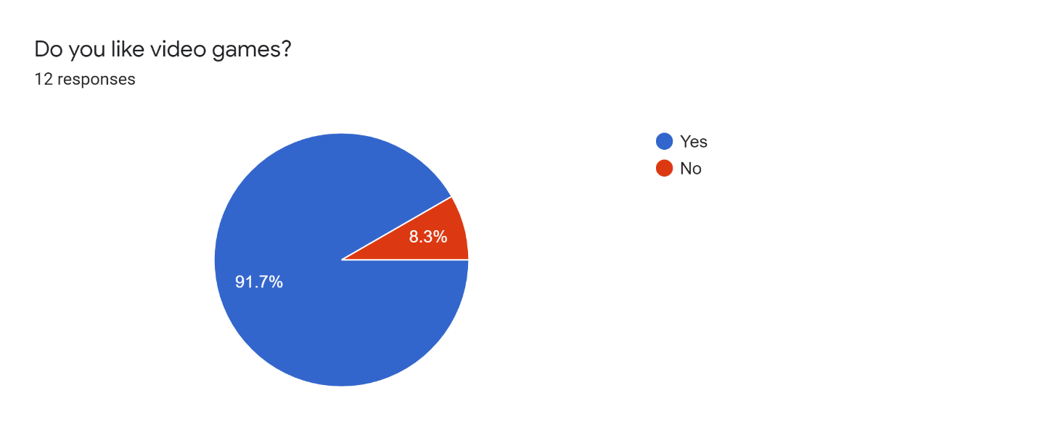

Figure 13 - Percentage of participants that like video games

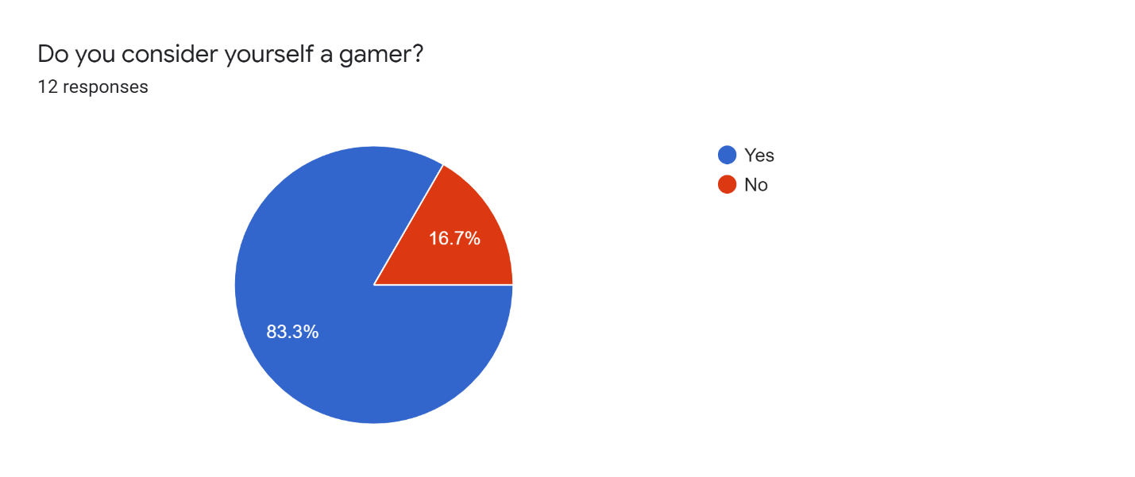

Figure 14 - Percentage of participants that consider themselves a gamer

These initial questions were asked to understand what background the participants were coming from, most of the participants were people that play video games.

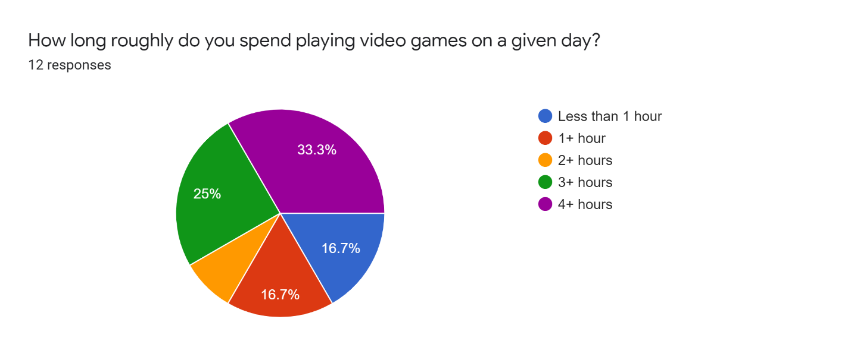

Figure 15 - Percentages of approximate play time on a given day

This question was asked to get approximate information about how much the survey participant plays games on a given day. The response indicated most participants spend more than 3 hours on a given day playing video games. This is good for the later survey questions as it shows most of the participants have a strong interest in video games.

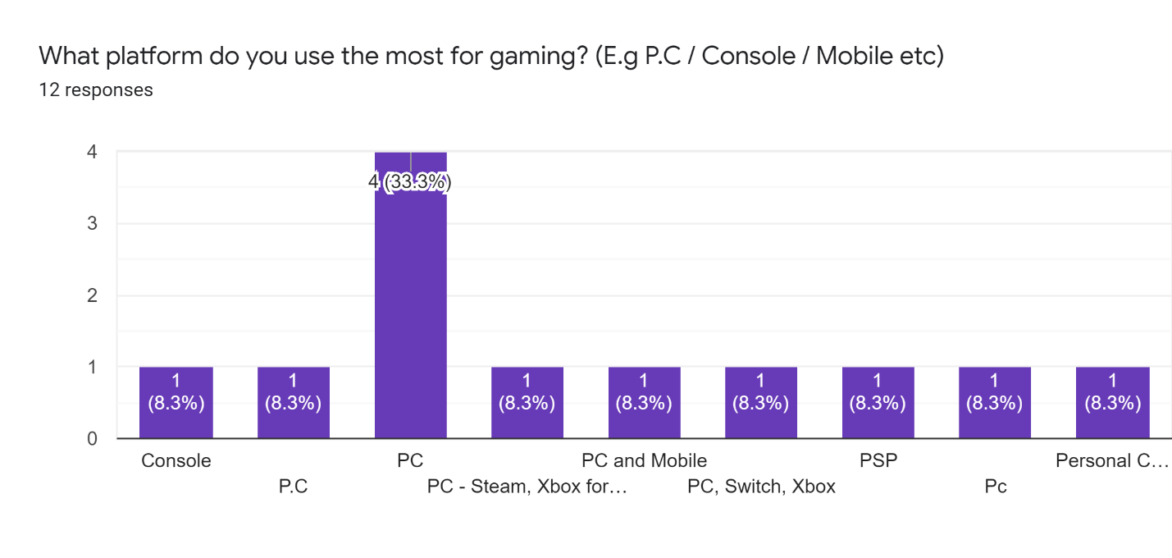

Figure 16 - Write-in information on participants choice for gaming platforms

This question in the survey allowed the participants to write their answer in as text. This is why there were multiple entries for the same thing (Pc, PC, P.C, Personal Computer). The survey allowed for write in answers as there are so many possible platforms to game on. Participants could write in answers as to not restrict the participants to choosing from a few. Despite this, 10 out of the 12 participants included P.C gaming in their answer, this is encouraging information as it is the platform that the game is targeting.

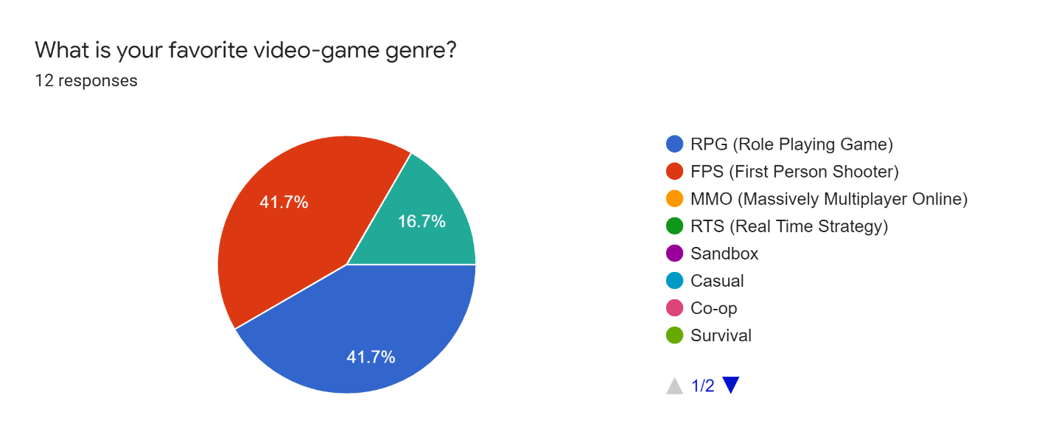

Figure 17 - Participant percentage answers for favourite video game genre (Page 1)

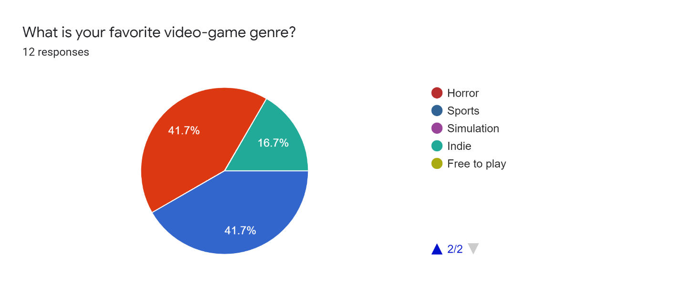

Figure 18 - Participant percentage answers for favourite video game genre (Page 2)

5 of the responses (41.7%) were for the FPS (First Person Shooter) genre as a favourite which is displayed in the pie chart as red. This genre is similar to Inertia’s, although Inertia would not be considered a First-Person Shooter, it does follow a similar theme and gameplay feel. It has similar movement and view mechanics; Inertia is also from the first-person view. 5 other responses were for the RPG (Role Playing Game) genre, this does not have any particular relevance to Inertia, as it strays far away from the RPG genre. The 2 final responses listed Indie games as their favourite video game genre, this genre refers to games that are self-published, created by independent developers rather than professional game studios, this directly coincides with Inertia, which would fall into the Indie genre category as it has two developers and no publisher.

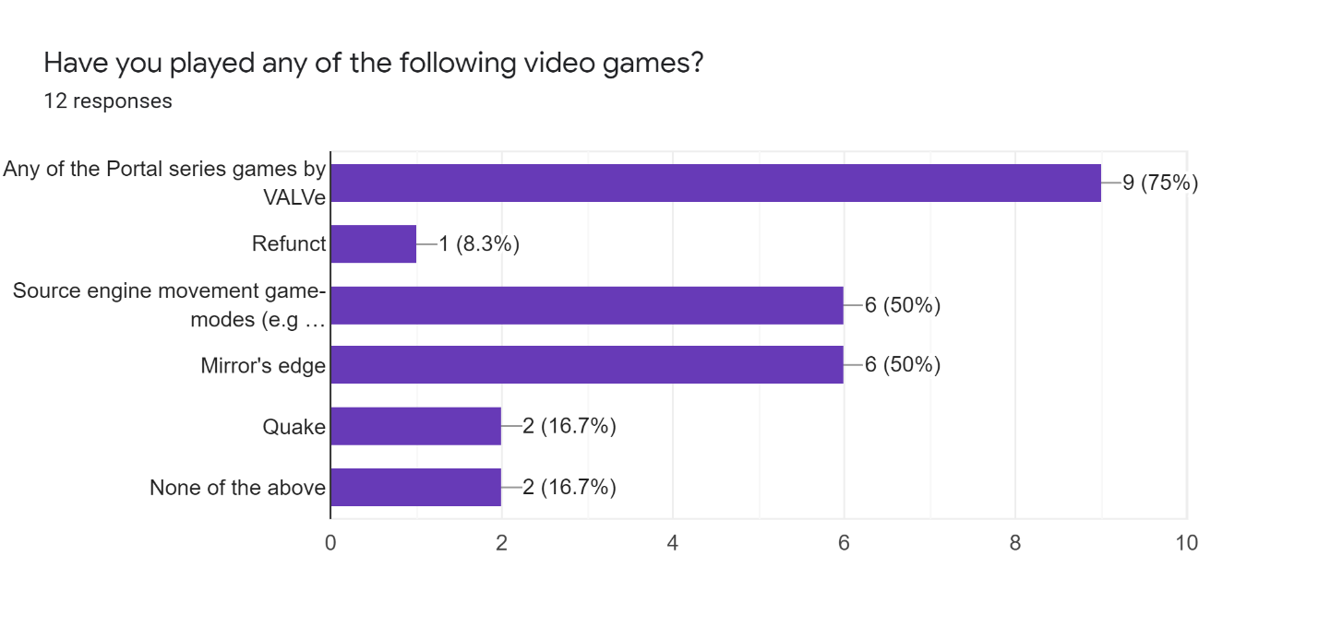

Figure 19 - Judging participant awareness to existing games similar to Inertia

This question was asked to find out what awareness and engagement there was for games that are similar to Inertia. 10 out of the 12 participants had played a similar game. All the games listed their cost money to play except for “Quake”, so this also indicates monetary interest in this type of game.

Participants were then given an optional section in the survey to answer, this contained footage of the video game ‘Refunct’. Refunct is an indie game developed mostly by a single developer, it is a simple movement game yet highly rated on the Steam platform for P.C. It was important to link this in the survey as it is an inspiration for Inertia’s development, 95% of the 14,077 reviews on steam for this game are positive as of 29th Oct 2020. The gameplay linked in the survey is located at this link: <https://www.youtube.com/watch?v=l1ypINE-igE>

Participants were asked to view a short portion of the clip and write in what they thought about it. The following images contain the text responses of the participants to the video clip. 11 out of 12 chose to respond to this part of the survey.

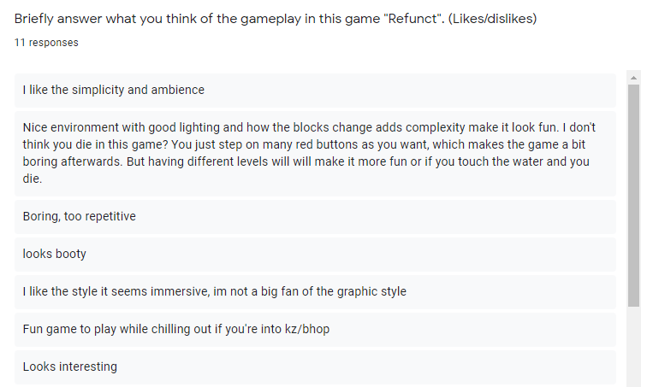

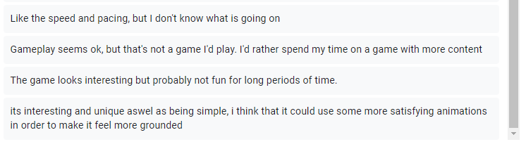

Figure 20 - Participant write in responses for the gameplay of Refunct

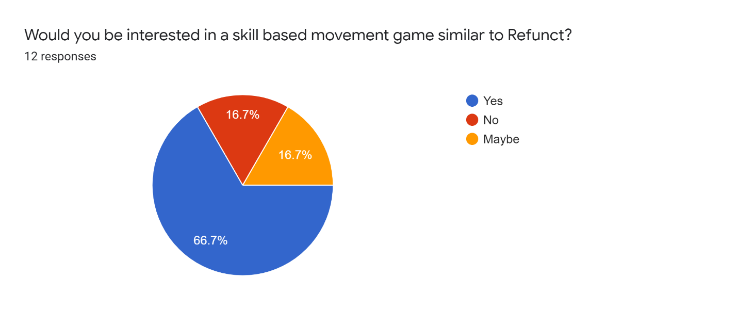

Figure 21 - Percentage of interest for a similar game to Refunct

This question was asked to determine the level of interest for a game like Refunct. 8 out of 12 participants (66.7%) indicated they would be interested, 2 indicated they might be interested, with the remaining 2 indicating they would not be interested. This is encouraging as it seems from this survey that there is some interest for a new game of this type.

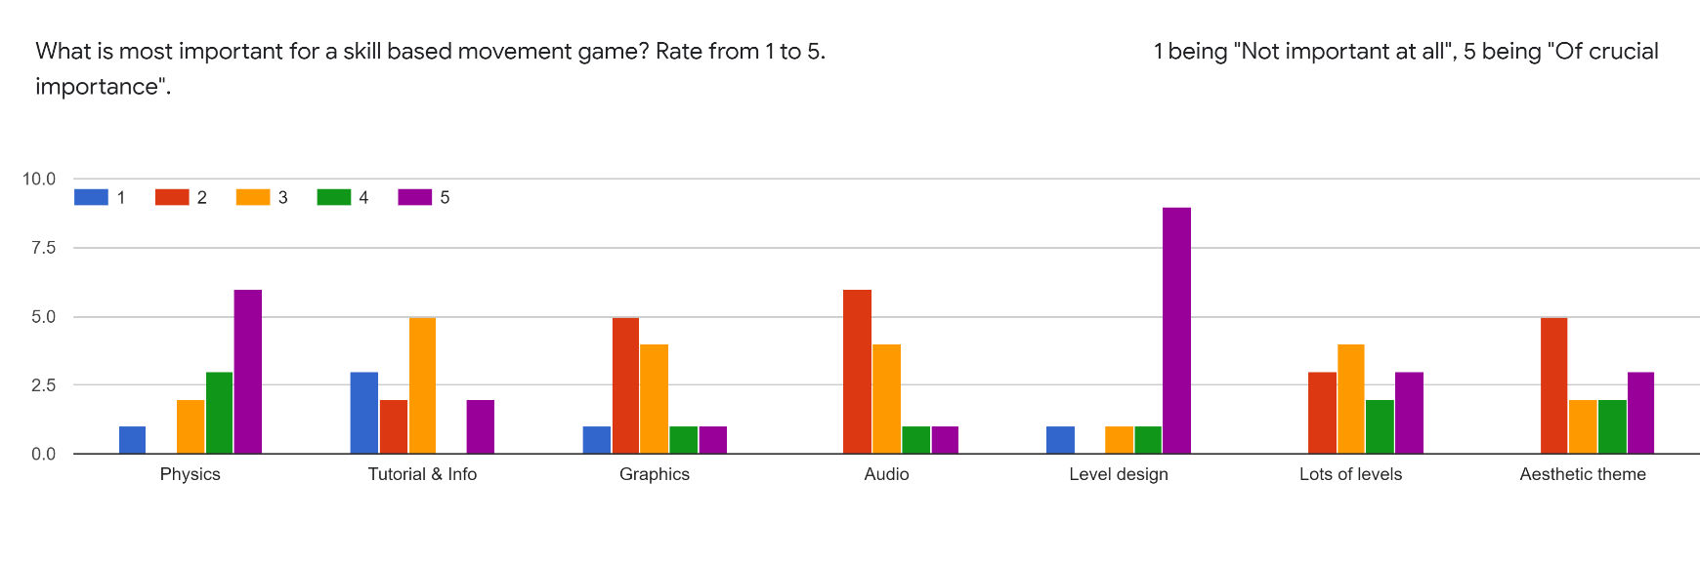

Figure 22 - Participant responses for importance of various aspects in Inertia’s game genre

This question gave crucial feedback into what participants thought was important for a game of this nature. Participants were asked to rate 1 – 5 the importance of various aspects of game design, 1 signifying “Not important at all” and 5 signifying “Of crucial importance”.

Summarizing the average results of the answers to this question, level design is the most crucial part of the game design for this genre (with 9 participants responding that it was “Of crucial importance”), followed by physics mechanics. Tutorial & informational mechanics, and aesthetic theme were of average importance to the participants. Audio and graphics were of low importance to most participants. There was dispute on the answer for the importance of the amount of levels needed in the game, though most answered that it was important.

From the collected responses it can be concluded that the game will need a strong focus on level design and physics mechanics. There is interest in the type of game that aligns with Inertia’s theme, and general interest in the genre it resides in. The majority of participants use P.C for gaming, so Inertia should continue to focus on targeting P.C gaming.

# Functional requirements

1. Full player-controlled movement around the play area.
2. Provide game levels adequate for player to interact with.
3. Adequate fundamental physics mechanisms (gravity, etc.).
4. Additional physics elements core to gameplay (grapple, etc.).
5. Level end conditions, a set objective which ends the level (Level can conclude).
6. Start screen / home screen (A way to launch game).
7. End state / end screen (Game can conclude).
8. Resetting on failure, preventing ‘softlocking’ player (Player can always progress).

# Non-functional requirements

1. Optimizing scripts so that they do not cause unnecessary lag / performance issues.
2. Creating levels of adequate difficulty, so they are not too easy or too hard.
3. Ensuring there are as few bugs as possible which could hinder gameplay.
4. Make game and menus as intuitive as possible, so players do not need to spend lots of time learning how to play or use the menus.
5. The graphics and models should be adequate.
6. Sound effects and music.
7. Experience enhancing graphical features such as field of view change on acceleration.
8. Making the game fun, above all else the game must be fun for a player to want to play it.

# 

Figure 23 - Use Case Diagram

# Use Case Diagram

In the following explanations, “Player”, refers to the Player actor, which is the user. For this use case diagram, there is only one actor. There is only the Player interacting with this game, as it is a single-player game. The rectangle represents the system, which in this use case diagram is the game, titled Inertia.

The first base use case is “Start Game”. This describes when the Player launches the game and arrives at the main menu. Functionality must be there to boot the game and load all the assets and game code into memory, ensuring the game is launchable. One of the included use cases for this is to “Load Saved Settings”, this will load the settings from the local storage on the computer, so that settings preferences would not have to be re-entered every time the game is launched. If this is the first time the Player actor is playing the game, the game will load the default settings.

Next base use case is “Change Settings”. This includes the use case “Load Saved Settings” also, ensuring that the settings the Player is changing is up to date with their previous changes (if any). The use case “Restore Default Settings” is extended, this functionality is needed if the Player has accidentally messed up their settings and wishes to restore the original settings the game came with, or as a way to restore if the Players settings somehow became corrupted. “Change Controls” is extended, this allows the Player to change the input controls that allow them to move around the world and interact with the game. “Change Difficulty” is extended, allowing the Player to modify the difficulty of the game, the exact implementation of this functionality is still in early development phases and planning, but will make the game more difficult or easier depending on the setting.

Third base use case is “Play Level”. This is the use case that describes all the gameplay of an individual level in the game. The Player will have a way to access this functionality through the main menu (represented by the “Start Game” use case). This is the main use case of the game, the Player will navigate the world and will (likely) attempt to complete the objective of the level, which would be to reach a certain point in the level. This base use case extends “Pause Game” use case, allowing the player to pause the game in time, useful if they need to take a momentary break from playing but do not wish for their progress in the game to reset. Also extended is the “Restart Game” use case, this allows the Player to restart the game if they want to abandon their current progress and return to the start of the game. “Record Time Taken” is included here, which will record the time it takes the Player to complete a level.

The fourth base use case is “Complete Game”. This is the functionality the Player invokes when they complete all objectives of all levels. The exact implementation of this use case is also still in development. It may run a routine script of displaying credits and returning to the main menu, saving the time if it beat all previous completion times. “Record Time Taken” is also included here, this is the functionality that will record the time it took to complete all levels of the game, and save it to local storage if it beats all previous Player records.

# Feasibility

This game is going to be developed in the Unity game engine, in the 3D game creator. The game developers decided to keep a common unity version and not update it during this project (Unity version 2020.1.6f1). For sharing individual progress with each other, they will use the in-built unity collaborate tool. They both signed up with their student accounts to get Unity Pro for free, which makes sharing the project easier. The project is periodically pushed to a private GitHub repository, this is to keep a version history, keep track of updates and as a backup in case something goes wrong. The Unity asset store will be used for getting some free assets for the game, this can be a source of problems as the target version of the assets on the store do not always match up with the version in use for the game. This can be circumvented by either manually updating the assets or ensuring not to use out of date assets.

For model and texture creation, 3D computer graphics software called Blender will be used. For images and icons, Photoshop will be used. The website Trello (https://trello.com/en) is being used for planning and development. Instant messaging and VoIP software, Discord, is being used to coordinate team effort. There are periodic meetings on discord to discuss progress and ideas, as well as problems and brainstorm solutions to bugs.

# Conclusion

This requirements chapter helped solidify direction and purpose with the game. The game will be developed with the results of the survey in mind, as well as the existing similar games of competitors. Due to this requirements chapter it was possible to map out goals for the game more clearly, it is now more obvious which aspects of the game’s development will need the most focus and time. The goals for the game are now more clearly defined. Ideas and inspiration have been drawn from existing successful games in this field, to be implemented within the game.

The information from the surveys conducted was particularly helpful. It is now planned to continue developing for the P.C platform, mobile game development was briefly considered. The most important areas of the game are more clearly understood, for example the survey results suggest the developers should focus development more on level design than on audio for this genre of game. Other feedback from the survey suggests that existing games in the genre can lack an exciting edge, this has prompted further investigation into more exciting game concepts such as grapple hook movement.

Outlining the exact requirements allows the developers to plan, the workload is now easier to judge. Knowing exactly what is needed for this game to be finished makes it much simpler to gauge progress and set deadlines. Game features which were previously in limbo have now been either scrapped or kept based on this segment of surveying and viewing competitor games, which massively solidifies the direction of this project.

# Tools and information

Use case diagram creator: <https://lucid.app/lucidchart/>

Use case diagram for a game info: <https://stackoverflow.com/questions/58031632/am-i-heading-in-the-right-direction-with-my-use-case-diagram>

Use case diagram creation information: <https://www.youtube.com/watch?v=zid-MVo7M-E>

Refunct reviews: https://store.steampowered.com/app/406150/Refunct/

Game survey: <https://forms.gle/SbSP3fNUuBd14RkA7>

Trello (used for coordination): <https://trello.com/en>

Discord (used for development chat): https://discord.com/